**Online Diary – Strategic and Twitch Skills**

Groups Members – Connor Winspur, Steven Smith, Joshua Wyre.

1. **- Overview and Game Description**

The team was tasked with designing a game with either strategic or twitch skill to a specific brief prepared. In response to this the team made a bomb defusal game that uses strategic skills.

The objective of the game was to defuse a bomb from a chosen number of cards. The players will receive cards at the start of the game and will need to decide what cards need to be used in order to defuse the bomb. Once ten minutes have passed, players will need to select one tool from the hand to defuse the bomb and try and win the game. This was designed to be played with 2 – 4 players working together to achieve the objective.

**4.1 – Materials**

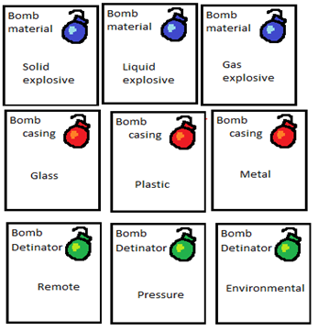The only materials needed for this game is the cards provided.

[B]

[A]

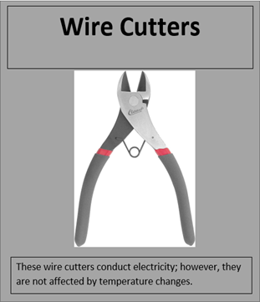

Figure 4.1. Game Cards

This scene shows the cards that are used during the game with [A] showing the materials that make the bomb and [B] showing an example of a defusal card.

The game has three types of cards with the bomb materials being displayed in Figure 4.1 [A], defusal items in Figure 4.1 [B] which consist of;

* Wire Cutters
* Defusal Robot
* Disruptor
* Disarmer
* Water Jet Cutting System
* Mine Prodder
* Laser Sight
* Window Breaker,
* Non-magnetic Tool Kit
* Crump Tool

The last det of cards are chance or disruption cards which consist of;

* Discard a random card
* Reshuffle your hand and the deck
* Minus two minutes on the timer
* Bomb attribute changes

**4.2 – Rules and Mechanics**

* Draw three bomb cards to see the attributes of your bomb.
* Draw three cards for each player from the defusal tool deck.
* Players can only hold three cards at one time.
* Players can discard cards and draw new ones
* Players need to discuss and decide which cards to play at the end of the game so none of their cards can detonate the bomb.
* Each player can only play one card at the end of the game.

**4.3 – Play Testing**

The team was only able to complete internal game testing due to time constraints. During this testing it was found that in the original build there were too many cards, so some were removed in order to simplify the game. It was also found that it was too easy to figure out which cards were needed to defuse the bomb based on the card descriptions.

[A]

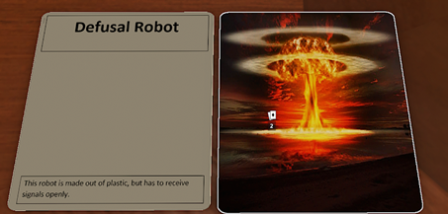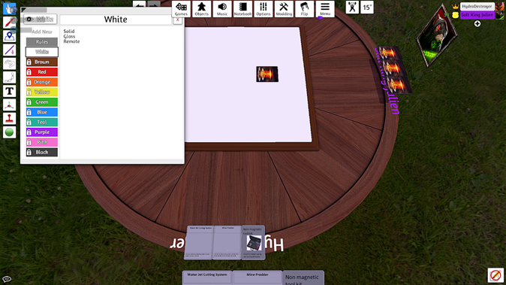

[B]

Figure 4.2. Game test and card render.

This scene shows a render of the game, made in Tabletop Simulator, with [A] showing the play testing and [B] showing a render of the cards that were made.

**4.4 – Experience and Skills Learnt**

During this task the team initially found it difficult to both decide on which of the two projects to do and also how to make sure the game fit the brief. After this this team worked efficiently with the time provided by dividing up tasks between the members. However when it came to play testing the team struggled due to not being able to find a method to make a working game, until the use of Tabletop Simulator was employed.